Database System Engineering and Distributed Backend Development
Name : B. Devi Charitha
Roll No : 2520030462

WEEK-2
Problem Statement 1: SkyTrack Airline Management System
Step 1 : Create Database CREATE DATABASE skytrack_db; USE skytrack_db;

Step 2: Create Flights Table
CREATE TABLE Flights ( flight_id INT PRIMARY KEY,
flight_number VARCHAR(10) UNIQUE NOT NULL, source VARCHAR(50) NOT NULL,
destination VARCHAR(50) NOT NULL, departure_date DATE NOT NULL,
ticket_price DECIMAL(10,2) CHECK (ticket_price > 0)
);

Step 3 : Create Passengers Table
CREATE TABLE Passengers ( passenger_id INT PRIMARY KEY,
passenger_name VARCHAR(100) NOT NULL, email VARCHAR(100) UNIQUE NOT NULL
);

Step 4 : Create Bookings Table
CREATE TABLE Bookings ( booking_id INT PRIMARY KEY, passenger_id INT,
flight_id INT, booking_date DATE,
FOREIGN KEY (passenger_id) REFERENCES Passengers(passenger_id), FOREIGN KEY (flight_id) REFERENCES Flights(flight_id)
);

Step 5 : Insert Records into Flights

INSERT INTO Flights VALUES (101,'AI105','Hyderabad','Delhi','2026-08-10',5500),
(102,'AI104','Delhi','Mumbai','2026-08-11',4500),
(103,'AI102','Mumbai','Bangalore','2026-08-12',3500),
(104,'AI103','Hyderabad','Chennai','2026-08-13',3000),
(105,'AI101','Chennai','Kolkata','2026-08-14',5000),
(106,'AI107','Delhi','Hyderabad','2026-08-15',5400),
(107,'AI108','Mumbai','Delhi','2026-08-16',4700),
(108,'AI106','Bangalore','Hyderabad','2026-08-17',3300),
(109,'AI109','Hyderabad','Goa','2026-08-18',4000),
(110,'AI110','Goa','Delhi','2026-08-19',5200);
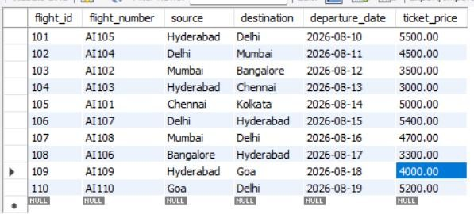
Step 6 : Display Table SELECT * FROM Flights; OUTPUT

Step 7: Insert Records into Passengers
INSERT INTO Passengers VALUES
(1,'K.Sai Samyuktha','samyuktha@gmail.com'), (2,'Chaitra Reddy','chaitra@gmail.com'), (3,’Veda Priya’ ,'veda@gmail.com'), (4,'Charitha','charitha@gmail.com'),
(5,'Vikram Rao','vikram@gmail.com'), (6,'Aditi Gupta','aditi@gmail.com'), (7,'Kiran Kumar','kiran@gmail.com'), (8,'Hamsika','hamsika@gmail.com'), (9,'Rohan Kumar','rohan@gmail.com'), (10,'Pooja Nair','pooja@gmail.com'); Step 8 : Display Table

SELECT * FROM Passengers;

OUTPUT
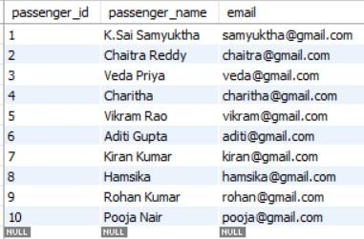
Step 9: Insert Records into Bookings INSERT INTO Bookings VALUES (1001,1,101,'2026-08-01'),
(1002,2,102,'2026-08-01'),
(1003,3,103,'2026-08-02'),
(1004,4,104,'2026-08-02'),
(1005,5,105,'2026-08-03'),
(1006,6,106,'2026-08-03'),
(1007,7,107,'2026-08-04'),
(1008,8,108,'2026-08-04'),
(1009,9,109,'2026-08-05'),
(1010,10,110,'2026-08-05');
Step 10 : Display Table SELECT * FROM Bookings; OUTPUT
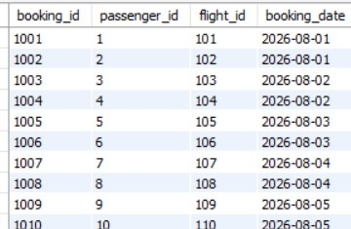

Step 11 : INNER JOIN
SELECT
P.passenger_name, F.flight_number,

F.source, F.destination FROM Bookings B
INNER JOIN Passengers P
ON B.passenger_id=P.passenger_id INNER JOIN Flights F
ON B.flight_id=F.flight_id;

OUTPUT
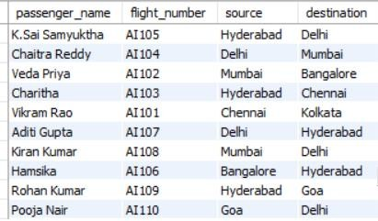

Step 12 : COUNT() and GROUP BY
SELECT
destination,
COUNT(*) AS total_flights FROM Flights
GROUP BY destination;

OUTPUT
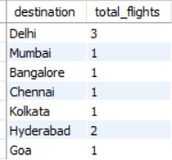

Step 13 : Create Flight_History Table
CREATE TABLE Flight_History ( history_id INT PRIMARY KEY, flight_id INT,
flight_number VARCHAR(10), source VARCHAR(50), destination VARCHAR(50), action_date DATETIME

);

Step 14: Transaction Example
START TRANSACTION;
INSERT INTO Flights VALUES
(111,'AI111','Hyderabad','Pune','2026-08-20',4200);
INSERT INTO Flight_History VALUES
(1,111,'AI111','Hyderabad','Pune',NOW()); COMMIT;

Step 15: Create Index
CREATE INDEX idx_flight_number ON Flights(flight_number);

Step 16: Search Using Index
SELECT *
FROM Flights
WHERE flight_number='AI105';

OUTPUT
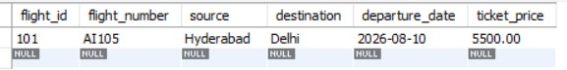

Step 17:Search by Destination
SELECT *
FROM Flights
WHERE destination='Delhi';
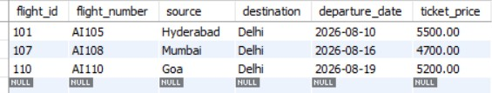
Why is searching by flight_number faster?
Searching by flight_number is faster because each flight has a unique number. The database can quickly find the required flight without checking every record. This saves time and improves the speed of data retrieval, especially when the table contains many records.

Problem Statement 2: MediCare Hospital Management System
Step 1 : Create Database CREATE DATABASE medicare_db; USE medicare_db;

Step 2: Create Doctors Table
CREATE TABLE Doctors ( doctor_id INT PRIMARY KEY,
doctor_name VARCHAR(100) NOT NULL, specialization VARCHAR(50) NOT NULL,
consultation_fee DECIMAL(8,2) CHECK (consultation_fee > 0)
);

Step 3: Create Patients Table
CREATE TABLE Patients ( patient_id INT PRIMARY KEY,
patient_name VARCHAR(100) NOT NULL, email VARCHAR(100) UNIQUE NOT NULL
);

Step 4: Create Appointments Table
CREATE TABLE Appointments ( appointment_id INT PRIMARY KEY, doctor_id INT,
patient_id INT,
appointment_date DATE NOT NULL,
FOREIGN KEY (doctor_id) REFERENCES Doctors(doctor_id), FOREIGN KEY (patient_id) REFERENCES Patients(patient_id)
);

Step 5: Insert Records into Doctors
INSERT INTO Doctors VALUES
(101,'Dr. Amrutha','Cardiology',800),
(102,'Dr. Veda','Neurology',700),
(103,'Dr. Harini','Orthopedics',900), (104,'Dr. Charitha','Pediatrics',600), (105,'Dr. Ravi','Dermatology',800),

(106,'Dr. Hamsika','Cardiology',850), (107,'Dr. Nandhini','Gynecology',750), (108,'Dr. Samyuktha','ENT',650),
(109,'Dr. Anjali','Ophthalmology',550), (110,'Dr. Sameeksha','General Medicine',400); Step 6: Display Table
SELECT * FROM Doctors;

OUTPUT
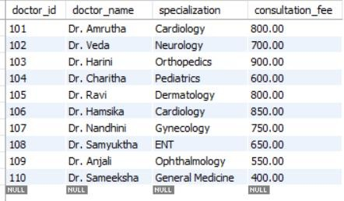

Step 7: Insert Records into Patients INSERT INTO Patients VALUES
(201,'Rajesh Kumar','rajesh@gmail.com'), (202,'Neha Sharma','neha@gmail.com'), (203,'Priya Reddy','priya@gmail.com'), (204,'Pooja Singh','pooja@gmail.com'), (205,'Arjun Rao','arjun@gmail.com'), (206,'Divya Patel','divya@gmail.com'), (207,'Kiran Das','kiran@gmail.com'), (208,'Aditi Gupta','aditi@gmail.com'), (209,'Nandhini Verma','nandhini@gmail.com'), (210,'Anil Kumar','anil@gmail.com');
Step 8: Display Table SELECT * FROM Patients; OUTPUT

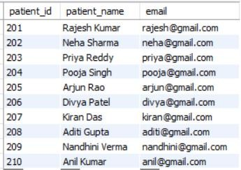
Step 9 : Insert Records into Appointments INSERT INTO Appointments VALUES (1,101,201,'2026-08-05'),
(2,102,202,'2026-08-06'),
(3,103,203,'2026-08-07'),
(4,104,204,'2026-08-08'),
(5,105,205,'2026-08-09'),
(6,106,206,'2026-08-10'),
(7,107,207,'2026-08-11'),
(8,108,208,'2026-08-12'),
(9,109,209,'2026-08-13'),
(10,110,210,'2026-08-14');
Step 10: Display Table SELECT * FROM Appointments; OUTPUT
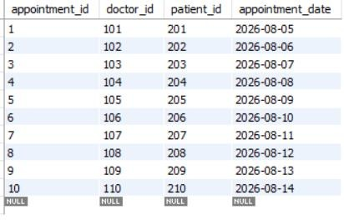

Step 11: INNER JOIN
SELECT
P.patient_name, D.doctor_name,

D.specialization, A.appointment_date FROM Appointments A INNER JOIN Patients P
ON A.patient_id = P.patient_id INNER JOIN Doctors D
ON A.doctor_id = D.doctor_id;

OUTPUT
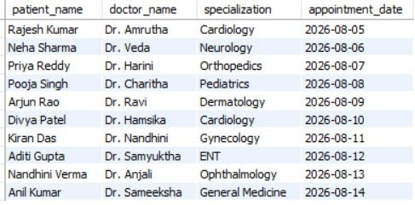

Step 12: COUNT() and GROUP BY Report
SELECT
specialization,
COUNT(*) AS total_doctors FROM Doctors
GROUP BY specialization;

OUTPUT
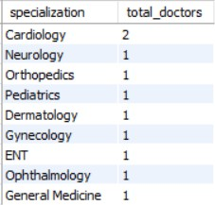

Step 13: Create Doctor_History Table
CREATE TABLE Doctor_History (
history_id INT AUTO_INCREMENT PRIMARY KEY,
doctor_id INT,
doctor_name VARCHAR(100), specialization VARCHAR(50),

registration_date DATE
);

Step 14: Transaction
START TRANSACTION;
INSERT INTO Doctors VALUES
(111,'Dr. Kavya','Oncology',950);
INSERT INTO Doctor_History
(doctor_id, doctor_name, specialization, registration_date) VALUES
(111,'Dr. Kavya','Oncology',CURDATE()); COMMIT;

Step 15: Create Index
CREATE INDEX idx_specialization ON Doctors(specialization);

Step 16: Search Using Index
SELECT *
FROM Doctors
WHERE specialization='Cardiology';

OUTPUT
